PROJECT REPORT  
  
  
THE TRAGEDY OF FLIGHT: A COMPREHENSIVE CRASH ANALYSIS  
  
  
TDMNS COLLEGE  
  
T.KALLIKULAM  
  
DEPARTMENT: PHYSICS  
  
TEAM:  
  
R.ANISH  
  
A.LENIN CHRISTOPHER  
  
S.GOKUL  
  
M.SUDARMANI  
  
  
the tragedy of flight: A Comprehensive Crash Analysis

introduction:  
  
project description:  
  
  
The first aircraft accident in which 200 or more people died occurred on March 3, 1974, when 346 died in the crash of Turkish Airline Flight981. As of April 2020, there have been 33 aviation incidents in which 200 or more people died. The aircraft, registered TC-JAV, was a McDonnells Dougles DC-10 that crashed into a forest situated northeast of paris. The London-bound plane crashed shortly after taking off from Orly airport; all 346 people on board died. It was later determined that the cargo door detached, which caused an explosive decompression; this caused the floor just above to collapse. The collapsed floor severed the control cables, which left the pilots without control of the elevators, the rudder and No. 2 engine. The plane entered a steep dive and crashed. It was the deadliest plane crash of all time until the Tenerife disaster in 1977. It is currently the deadliest single-aircraft crash with no survivors.

The top 10 countries with the highest number of fatal civil airliner accidents from 1945 to 2021 are the United States, Russia, Canada, Brazil, Colombia, United Kingdom, France, Indonesia, Mexico, and India. The United Kingdom is noted to have the highest number of air crashes in Europe, with a total of 110 air crashes within the time period, and Indonesia is the highest in Asia at 104, followed by India at 95.

The largest loss of life on board a single-aircraft is the 520 fatalities in the 1985 Japan Airlines Flight 123 accident, the largest loss of life in multiple aircraft in a single accident is the 583 fatalities in the two Boeing 747's that collided in the 1977 Tenerife airport disaster, while the largest loss of life overall in a collective incident is the 2,996 fatalities in the coordinated terrorist destruction of airplanes and occupied buildings in the 2001 September 11 attacks.

uses of this project:  
  
  
Air accidents present a formidable range of challenges to organisations charged with providing a response. Such accidents can be hugely variable in scale and nature, occurring in almost any location at any time of day.

On occasions, the accidents may involve a major international emergency response. The range of tasks in response to an aircraft accident are designed to rescue survivors, identify victims, protect the public and conduct appropriate investigations into the accident causes. This course aims to provide an overview of what you may expect to encounter at an accident site and how to effectively manage the critical first hours of any emergency response.

Problem definition &design thinking  
  
Empathy Map:  
  
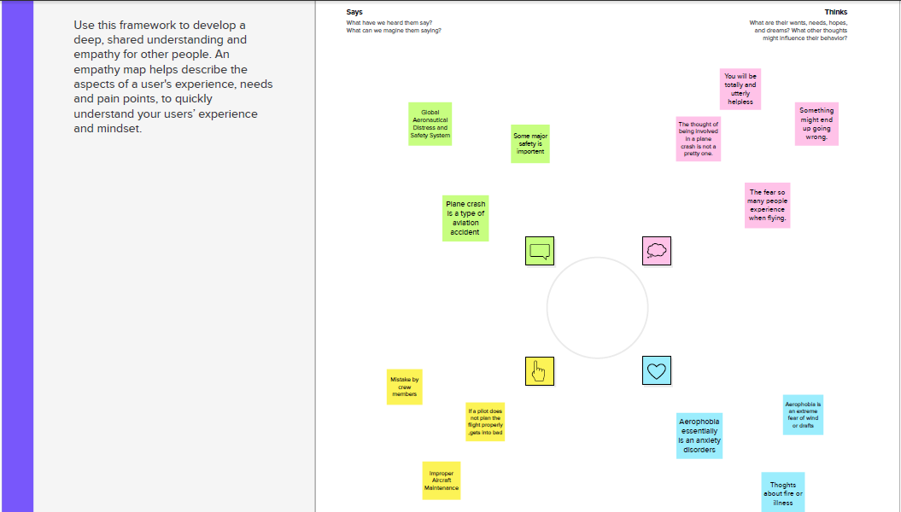  
  
  
Ideation& Brainstorming Map:  
  
  
  
  
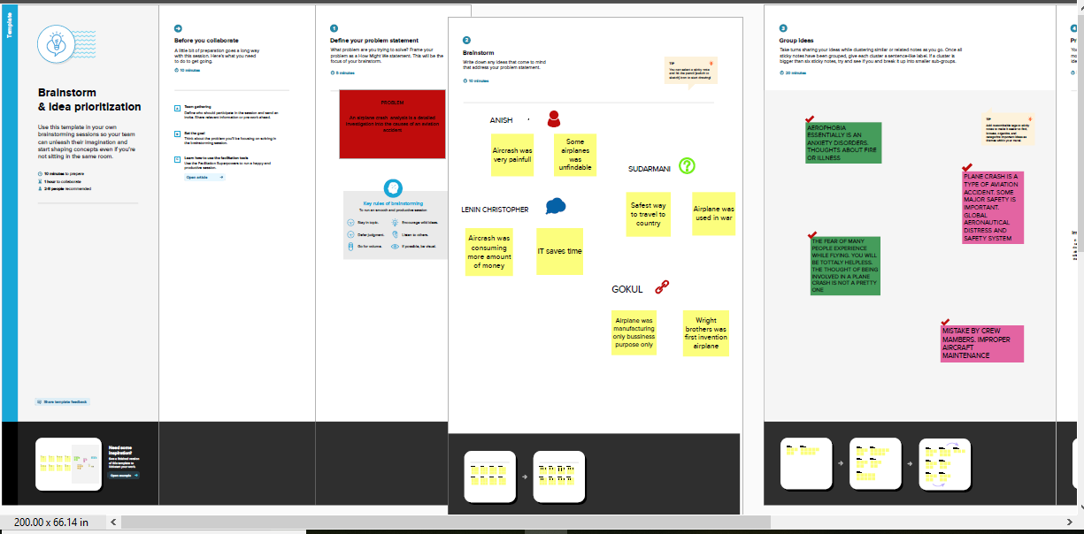  
  
  
  
  
  
  
  
  
  
  
  
  
Result:  
  
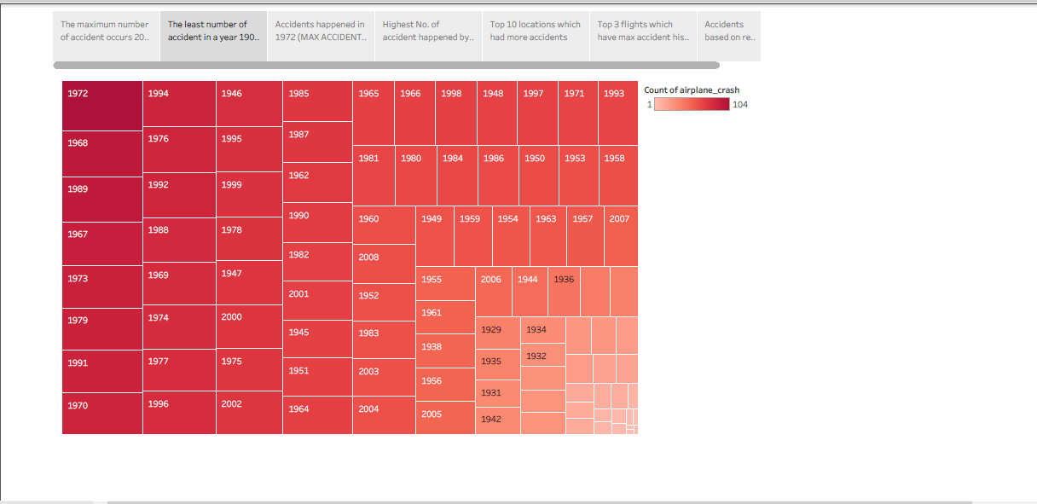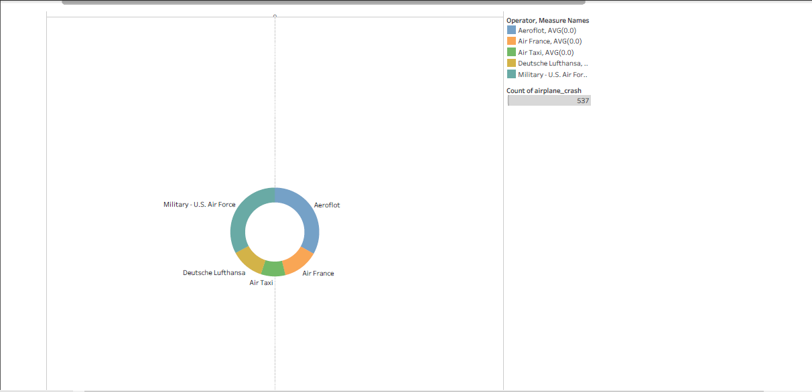  
  
  
  
  
ADVANTAGES&DISADVANTAGES  
  
  
 Short transit time in approximately 1 to a week of international transit.

Flights are not usually delayed.

The flights are usually daily and not weekly, as is the case with maritime departures, and this allows the reservation, collection, delivery of merchandise at the airport terminal and departure to be quickly coordinated.  
  
The original air waybill or AWBL travels with the merchandise. They cannot be used as a method of retaining merchandise.

It is not advised for letters of credit for the reason stated above.

Depending on the type of aircraft, there is a maximum height for the pallets, otherwise freighters should be used.

APPLICATIONS:  
  
  
The original air waybill or AWBL travels with the merchandise. They cannot be used as a method of retaining merchandise.

It is not advised for letters of credit for the reason stated above.

Depending on the type of aircraft, there is a maximum height for the pallets, otherwise freighters should be used.

Conclusion:  
  
The original air waybill or AWBL travels with the merchandise. They cannot be used as a method of retaining merchandise.

It is not advised for letters of credit for the reason stated above.

Depending on the type of aircraft, there is a maximum height for the pallets, otherwise freighters should be used.

FUTURE SCOPE:  
  
  
**1. Fly on Nonstop Routings**

Most accidents occur during the takeoff, climb, descent, and landing phase of flight so flying nonstop would reduce exposure to these most accident prone phases of flight.

**2. Choose Larger Aircraft**

Currently, aircraft with more than 30 passenger seats were all designed and certified under the strictest regulations. Also, in the unlikely event of a serious accident, larger aircraft provide a better opportunity for passenger survival.

**3. Pay Attention to the Preflight Briefing**

Although the information seems repetitious, the locations of the closest emergency exits may be different depending on the aircraft that you fly on and seat you are in.

**4. Keep the Overhead Storage Bin Free of Heavy Articles**

Overhead storage bins may not be able to hold very heavy objects during turbulence, so if you or another passenger have trouble lifting an article into the bin, have it stored elsewhere.

**5. Keep Your Seat Belt Fastened While You are Seated**

Keeping the belt on when you are seated provides that extra protection you might need if the plane hits unexpected turbulence.

**6. Listen to the Flight Attendants**

The primary reason flight attendants are on an aircraft is for safety, so if one of them asks you to do something like fasten your seat belts, do it first and ask questions later.

**7. Don’t Bring Any Hazardous Material**

There are rather long lists of hazardous materials that are not allowed, but common sense should tell you that you shouldn’t bring gasoline, corrosives, poisonous gases, and other such items on the aircraft unless they were allowed by the airline and shipped in a proper container.

**8. Let the Flight Attendant Pour Your Hot Drinks**

Flight attendants are trained to handle hot drinks like coffee or tea in a crowded aisle on a moving aircraft, so allow them to pour the drink and hand it too you.

**9. Don’t Drink Too Much**

The atmosphere in an airliner cabin is pressurized to about the same altitude as Denver, so any alcohol you consume will affect you more strongly than at sea level. Moderation is a good policy at any altitude.

**10. Keep Your Wits About You**

In the unlikely event that you are involved in an emergency .